# Multiple-Choice Questions

The system stack must provide space for:

* Processor registers in as many copies as there are interrupt lines +1

Twice consecutive execution in one process of operation P on a raised binary semaphore:

* Causes the semaphore to get down
* If a semaphore guards a critical region, it leads to a deadlock

In UNIX, access rights are attributes:

* An entry in the I-node table

The kernel (microkernel) is responsible for:

* interrupt handling (at the elementary level, then they are passed on to other layers)
* synchronization of processes and devices with processes
* task control

In multi-level interrupts (vectored interrupts) the jump is performed:

* according to the table indexed by the interrupt number

In UNIX, the disk contains the following areas:

* Files data
* I-node table
* SuperBlock

What is this technique where the operating system gathers programs and data together before processing?

* Batch processing

The page fault interrupt is used to:

* Downloads to the memory of the requested page

Scheduling algorithms can be:

* Indulgent
* Preemptive

The resources of the computer system are:

* Primary memory
* Periphery devices
* Processor time

When is the scheduler called?

* at the end of the execution of each kernel procedure

A memory management technique in which the system divides memory into equal-sized portions to easily manage relocation is called:

* paging

What does the file system layer do?

* manage files
* Manages directories
* Manages free storage space

Indulgent scheduling is the best mechanism for:

* real-time system

What does the kernel do when there is no task (process) to run?

* Starts the idle task

The internal state of the program supervisor layer is available for:

* OS kernel

Discontinuous allocation is the result of:

* segmentation
* paging

Paging is in thrashing if:

* the system spends more time paging than execution

The return from interrupt instruction:

* restores the conditions register
* restores the program counter

Dynamic relocation requires the use of:

* Base register (DATUM)

A program compiled for execution in paged memory can be executed in regular memory.

* False

Page thrashing is a phenomenon involving:

* frequent downloading of pages that have just been swapped out from memory
* Frequent loading of pages that have just been ejected from memory

Semaphores are used to solve the problem:

* Mutual exclusion

Dirty frame is:

* modified

The common allocation queue to fixed blocks of memory of equal size causes:

* Internal fragmentation

Which scheduler needs to make a decision the fastest?

* short-term

In operating system:

* Every exception must be handled

Static relocation is performed by:

* compiler
* linker
* Loader

Operation V on a raised binary semaphore:

* It does not change the value of the semaphore

Fragmentation is implied by:

* Internal by paging
* Internal by partitioning into quantized blocks
* External by freeing blocks in a deallocation order not reverse to allocation
* External by resizing allocated blocks

A process can appear in the pool of scheduling processes as a result of:

* Performing V operation on the semaphore
* Completing an I/O operation
* Starting a new process

External fragmentation can be avoided by:

* Allocation of fixed size static memory blocks
* Freeing memory blocks in the reverse order to allocation

The Test-And-Set or Compare-And-Swap instruction has the following characteristics:

* Requires active waiting from tasks
* It is possible to use only on computers with common memory
* It is possible to deadlock with TAS/CAS operations on multiple variables

Using the Test-And-Set instruction in synchronization:

* It requires processes to actively wait

Address translation is handled by a unit called (give the abbreviation):

* MMU

Dynamic relocation:

* Requires hardware support in the form of a DATUM register
* Allows for temporal elimination of external fragmentation

Opening a file in UNIX writes the following entries in the operating system's data structures:

* Inserting a new entry into the Table of Active I-nodes or increasing the counter in an existing entry
* Inserting a new item into the Table of Open Files of the Process

What type of code can multiple processes execute simultaneously?

* reentrant

Address translation aims to:

* Converting a virtual address to a physical one

The optimal scheduling algorithm in terms of minimizing the average time in the system of a given task is:

* SJF

Inter-process communication can be organized using:

* Messages
* shared directly addressable memory fields
* shared memory fields accessible through system calls

Which of the following memory allocation schemes can cause external fragmentation?

* segmentation
* sweeping

For concurrency in OS:

* Interrupt handling is necessary

Which of the following information is stored on task switching?

* I/O status information
* scheduler data
* contents of general purpose registers, program counter, and similar registers available to the program
* Contents of datum, limit and other registers inaccessible to the program

The conversion of the effective address to the physical one takes place:

* In the memory management unit

The logical address is also:

* Effective address

Which of the following statements is true for system level threads?

* Kernel-level threads require their descriptors in the kernel

Address translation mechanism:

* Concatenates the frame number and offset on the page

The effective address is also:

* Logical address

Dynamic relocation is performed by:

* Paging system
* Special registers (DATUM)
* Segment descriptors

What is included in the context that must be maintained for a synchronous precision interrupt?

* general purpose registers
* program counter
* collective or individual interrupt mask

System/user threads:

* User-level thread descriptors are stored in the address space of the program
* User-level threads share the same execution context
* System level thread descriptors are stored in the operating system kernel

How is exception identification performed?

* the specification of hardware interrupts is given over the data bus

The combination of paging and segmentation consists in:

* the use of a segment table or a pool of segment registers treated as an additional, superior level of paging

The behavior of the exchange algorithm opposite to that expected with the measures taken is called:

* anomaly

The hardware resources of a computer system are:

* Processor time
* Primary memory
* Peripheral devices

How does the operating system call the task completion subroutine?

* 3. → builds an interrupt vector on the system stack pointing to the terminating subroutine code
* 2. → sets the trace in the terminating subroutine to the current position
* 4. → recreates the context programmatically and executes the IRET instruction
* 1. → builds the frame of the terminating subroutine on the task stack

What mechanism is part of time-sharing systems?

* Short-term scheduler
* low-level scheduler

On UNIX, the number of files is directly limited by:

* I-node table size
* The size of the space allocated for files

What are the functions of the kernel?

* Interrupt handling

What type of code can be executed simultaneously on multiple processors?

* reentrant

MMU uses index tables to:

* generating a physical address
* generate a physical address

To end the interrupt service, use the following instruction:

* Special return instruction

Physical address:

* points to a location in the address space of primary memory

In a FAT-based disk system, file size is directly limited by:

* The size of the disk space
* The number of bits of the field describing the size of the file

Threads in operating system:

* They share context except registers and stack

The page fault exception is specific in that:

* is reported in the "middle" of an instruction execution
* execution of the instruction may require decrementing the program counter
* continuation of the instruction execution may require the saving of internal processor registers storing intermediate values

Virtual memory consists of:

* Primary memory and storage memory
* primary and mass memory

The scheduling goal, which is to occupy processors as efficiently as possible, is:

* utilization

The use of timer interrupts is necessary:

* In multiuser systems

At the suspended state is a process that:

* Waits for an I/O operation to complete

Which of the following memory allocation schemes causes external fragmentation?

* Segmentation
* Multiple contiguous fixed partitions of various sizes

Which of the following interrupts a running process?

* Hardware interrupt
* Timer interrupts
* Power fail interrupt

Conditional variables in a monitor:

* They are used to suspend processes that cannot run because the conditions for their continuation are not met

In a FAT-based disk system (without sharing allocation units by files), the number of files is directly limited by:

* FAT table size
* The size of the disk space

The scheduler decisions take the form:

* change from ready to active state

Interrupt vector is saved in a case of:

* accepting a hardware interrupt
* accepting a non-maskable interrupt
* jump with trace

Allocation unit for file storage:

* must be constant across the disk partition
* may vary between partitions

FIRST-FIT algorithm:

* Causes external fragmentation

Processor access scheduling decisions may be made under which of the following circumstances?

* When a task goes from the active state to the waiting state
* When a task transitions from the active state to the ready state
* When a task goes from the waiting state to the ready state
* When a task terminates

The following situations cause the exceptions (processor internal interrupts) of the "error" type:

* a reference to memory that is not in the address space
* memory reference beyond limit register value
* an attempt to write to the page for which the "read only" bit is set

Multiprogram systems:

* It holds more than one program in primary memory at the same time

The direct resume rule means that:

* The resuming process loses the critical region
* The resuming process applies for the critical region just like other processes on monitor input

What is true for simultaneous execution in the same context?

* Threads minimize context switch time
* The use of threads ensures concurrency within the process
* A multiprocessor kernel can be concurrent

The following situations trigger "error" exceptions:

* attempting to execute an illegal instruction
* attempting to execute in user mode an instruction that is only legal in system mode
* a reference to memory that is not in the program address space
* memory reference beyond limit register value
* an attempt to execute an instruction from the area of the page for which the "no code" bit was set

When an exception is raised in user mode, the operating system switches to the kernel system stack, and what happens when an exception is raised in system mode?

* nothing special, it builds the context on the kernel system stack

The number of condition variables is by definition in the monitor:

* as many as there are different conditions for the continuation of processes

What mechanism is used to desynchronize processes with different relative speeds?

* buffer

Is IOW bit:

* Protection bit

Sequence of actions when starting a new task:

* 1. → filling in the descriptor in the kernel
* 2. → memory allocation if this is the first task of the program
* 3. → initialize the stack, fill the first frame
* 4. → instruction to transfer control to the task

A multiprogram system is one that, in principle:

* It allows for storing many programs in primary memory
* Requires relocation or equivalent mechanism

The common allocation queue to fixed blocks of memory of different sizes causes:

* internal fragmentation
* external fragmentation

If the compiler prepares a program with absolute addresses to be loaded in a fixed address space, it is called:

* Static relocation

During the interrupt handling:

* other interrupts may or may not be accepted at the discretion of the programmer

Scheduling aims to optimize:

* processor utilization
* system throughput
* wait time
* reaction time

The page index table address is stored in:

* page table base register

The file system layer plays the following role in the operating system:

* Performs file opening and closing operations
* It performs directory services in the hierarchy of disk files
* Controls file access rights

The algorithm in which the most recently loaded page is swapped out is called (enter the abbreviation if applicable):

* FIFO

In which swapping algorithms is the M bit value used?

* NRU

Using Test-And-Set or Compare-And-Swap in synchronization:

* It requires processes to actively wait
* It can only be applied in systems with shared memory

Memory partitioning into blocks of any size:

* It does not imply fragmentation

What can happen when a job leaves the critical section and more than 1 task is waiting for the critical section?

* starvation awaiting a critical section

The root directory of the disk should be located:

* in a place designated by the data structure in a fixed location on the disk

Which technique was introduced because a single task could occupy both the CPU and I/O devices?

* Interrupts

Individual interrupt mask:

* a register whose bits are ANDed (conjunction) with the bits from the interrupt request register

Which swapping algorithms use the current time slice number?

* Second chance
* Working set

Paging-two-level index tables mode of operation

* The content of a level 1 table element points to a level 2 table

What is a scheduler?

* a kernel routine that selects a task to execute

In indulgent scheduling, the process keeps the CPU until:

* waiving
* termination

Two successive executions of operation V in one process on a binary semaphore in down state:

* If the semaphore guards a critical region, it can lets two processes enter the critical region
* Raises the semaphore if there are no suspended processes

The operating system plays the following role in a computer system:

* Create a concurrent environment
* computer system resource management

What mechanism is used to save and restore the task state?

* Context switch

Internal fragmentation consists in:

* The program does not use all the memory allocated to it

The following paging exceptions allow for returning to the program after they occur:

* page fault
* interrupt on write (IOW)

For address translation, the following is used:

* index table
* associative translation buffer

In UNIX, access rights are specified:

* Individually for each file
* Separately for the user, the group to which the user belongs and for all others
* Separately for write, read and execute/search

Calling the program with the "exec" operation results in (accurately to the result of the exec operation):

* Loading code and data segments from disk, initializing a new stack segment

Scheduler function is:

* selecting a task to run

In the philosophers problem, if there are 4 of them:

* Deadlock is possible
* Starvation is not possible

The software resources of a computer system are:

* Files
* Buffers
* Semaphores

Which of the following memory allocation schemes causes external fragmentation?

* Sweeping
* Multiple contiguous fixed partitions of various sizes

Can the exchange algorithm: selecting a frame to empty and loading a new page, be performed in user mode?

* True

Interrupt mask:

* causes interrupts to be disabled when an interrupt is accepted
* can unblock interrupts when the interrupt handler completes
* can be set and reset by special processor instructions

Allocation unit for storing files:

* must be constant across the disk partition
* may vary between partitions

Which swapping algorithms use page reference history?

* LRU
* LFU

The thread is also called:

* Lightweight process

Round-robin scheduling is the best mechanism for:

* time-sharing system

Context switch is:

* writing registers to the task stack and retrieving them from another task stack

Separate allocation queues for fixed memory blocks of equal size cause:

* internal fragmentation
* external fragmentation

A multiuser system is one that, in principle:

* Must be concurrent
* Requires the use of timer interrupts

In which swapping algorithms is it necessary to collectively clear the M-bits?

* No algorithm

Interrupt request register is:

* a register where interrupt line states are stored

The internal state of the file system layer is available for:

* OS kernel
* Program supervisor layer

"Soft" real-time system:

* Guarantees average response time

The key in associative memory is:

* Page number

The sweeping mechanism consists in:

* Loading segments into primary memory and sending them to disk

The interrupt acceptance sequence consists of (in the sequence):

* identification of the interrupt level, saving the interrupt vector, performing a jump with a trace according to the interrupt table

Imprecise interrupts can be handled:

* after clearing the pipeline from the instructions
* after saving the full state of the pipeline

Logical address:

* points to a cell in the process address space
* is converted to a physical address in the address translation mechanism

Imprecise interrupts are:

* accepted in any state of the processor, not just between the execution of successive instructions

Internal fragmentation can be removed by:

* No response from the others

The mechanism for moving programs between primary memory and mass storage is called:

* sweeping

Semaphore function is to:

* Synchronize critical resources to prevent a deadlock

Between fork and exec operations, the following operations are performed:

* Opening the appropriate input/output files

The sweeping criteria include:

* Priority
* Program state
* Analysis of program execution history

The number of tasks performed on the system in a given time is:

* throughput

By definition, a deadlock is a situation where:

* any greater than zero number of processes are waiting for conditions that cannot be met

SJF selects the task:

* with the least CPU requirement

Which swapping algorithms use the history of page references (when was it last used or in which time slices was it used)?

* second chance
* LRU
* LFU
* working set

The page reference and modification bits are used to:

* counting references for swapping optimization

When the processor is released, the scheduler selects one of the queued processes:

* ready

The page error (page fault) interrupt is used to:

* download the requested page to the primary memory

Logical address is:

* effective address

In what states can a task occur?

* current
* ready
* blocked

The effective address is at the same time:

* logical address

The content of the last (lowest in the hierarchy) page index table is:

* frame

Two-level TIS - place frame no:

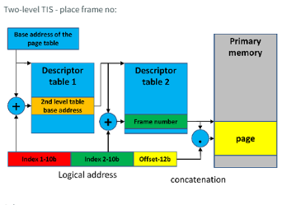

* in the table of the second level - on the right in the figure

The environment in which the process is executed includes:

* A set of environment variables
* Process address space
* General purpose registers content
* Open files

Which of the following applies to user-level threads?

* User-level threads cost no execution time in system mode

WORST-FIT algorithm:

* Requires a descending sort of the list of free blocks
* It allows for fast determining whether there is a free block of the required size
* It is designed to reduce external fragmentation
* Requires sorting the cut part into the list of free blocks

The hardware mechanisms necessary for paging are ("frame error" also called "page fault", "frame miss"):

* address translation, page index tables, "frame error" interrupt

Having two-level page index tables:

* the content of a level I table element points to a level II table

Which swapping algorithms use information about a reference to pages in the last k periods of time?

* working set
* working set clock

When a suspended program is moved to auxiliary memory, its process state is called:

* Swept away

Which of the following facilities or abilities are required to provide mutual exclusion support?

* A task that is performed outside the critical section must not affect the behavior of a task in the critical section.
* The task stays in its critical section only for a finite amount of time

If a linker prepares a program with absolute addresses to be loaded in a fixed address space, it is called:

* Static relocation

At the blocked state is a process that:

* waits for an I/O operation to complete

Collective interrupt mask is:

* a register that blocks or unblocks all interrupts

Which swapping algorithms can be implemented based on hardware support in the form of a collective reading of reference bits and collective clearing of these bits?

* LRU
* LFU

In a multitasking environment, the operating system decides which task the CPU gets, when, and for how long. This feature is called:

* Task scheduling

Is memory protection useless in a non-concurrent system?

* False

The program supervisor layer in the operating system has the following role:

* Intercepts all program system calls and routes them to the appropriate layers
* Runs programs
* Deals with the management of primary memory (memory allocation to programs)

A process always transitions from the "user" state to the "system" state as a result of:

* A software interrupt that calls a system function
* Debugger trap

At the ready state is a process that:

* Waits for a processor

The kernel is _______ user-level threads.

* unaware

After performing the mount(/dev/hd5,/usr/x/bin/hd5) operation, the file /usr/z/a on the mounted disk should be referenced by:

* /usr/x/bin/hd5/usr/z/a

In a concurrent environment, the operating system decides which task the CPU gets, when, and for how long. This feature is called:

* Task scheduling

# Open Questions

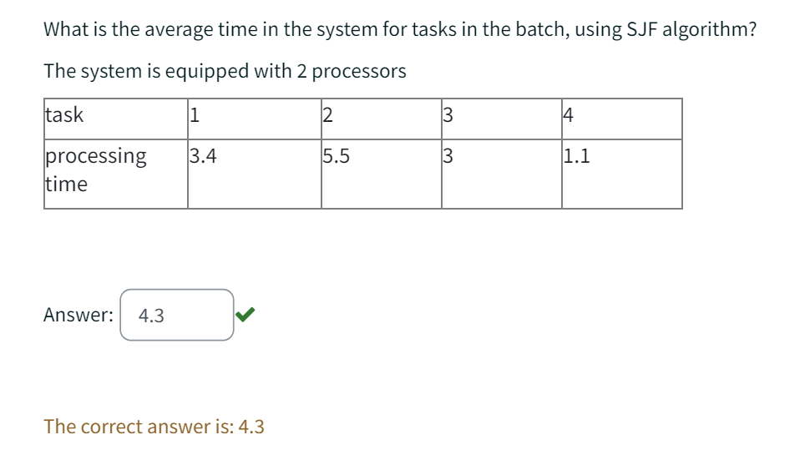

To figure out how to solve this, refer to [this](https://drive.google.com/file/d/15oa8TzEyRPwJRBw2DdiLhOK4agdB1sIK/view?usp=sharing)

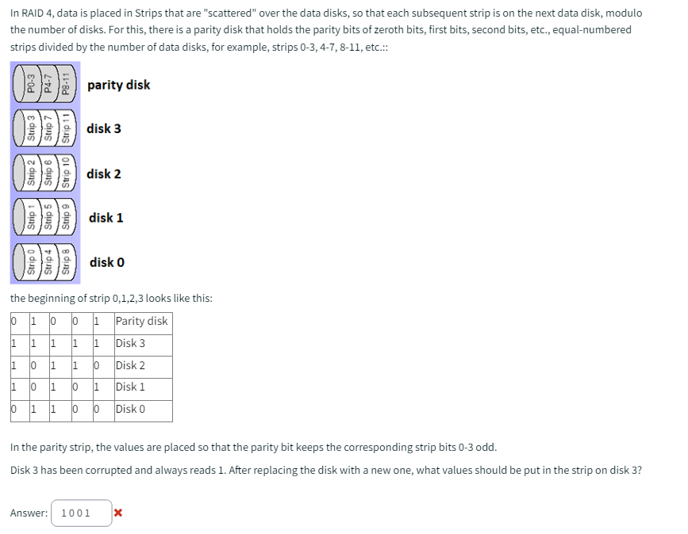

Assuming memory cells are 1-byte, the page number in the address field is 12 bits, the offset is 12 bits, the frame number is 10 bits, and all entries in the TIS page index table are on a 16-bit word boundary, enter:

-TIS maximum size of the program in kB

* 8